**World Quant University**

**Professor: Harry Wang**

**Algorithms II**

Nikolas Lippmann Pareschi - [nikolaslippmann@gmail.com](mailto:nikolaslippmann@gmail.com)

### Assignment 2:

### Problem :   Coin Changing

Consider the problem of making change for n cents using the fewest number of coins. Assume that each coin’s value is an integer. Describe a greedy algorithm to make change consisting of quarters, dimes, nickels, and pennies.

Code for the function which computes ALL the cases:

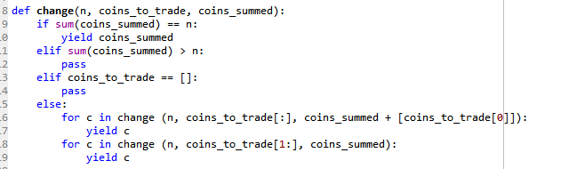

We used the yield so we return a generator and compute on the fly using less memory. Also it keeps running the loop until it hits yield. I learned that with this video in which the code is based [1] and also with this explanation [2].

We do these 2 fors:

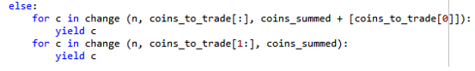

So we can repeat the change, supposing for example that we have several repetead coins (first for). But then again we need to jump fot the next coin in the list, so we use the next line of code.

In the last lines of code we print all the solution and take the solution which uses less coins:

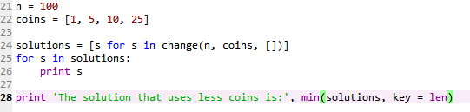

Some results printed in the console:

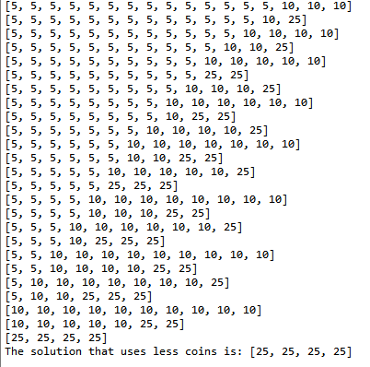

[1] <https://www.youtube.com/watch?v=EScqJEEKC10>

[2] <https://stackoverflow.com/questions/231767/what-does-the-yield-keyword-do?utm_medium=organic&utm_source=google_rich_qa&utm_campaign=google_rich_qa>